1)OOPs makes development and maintenance easier where as in Procedure-oriented programming language it is not easy to manage if code grows as project size grows.
2)OOPs provides data hiding whereas in Procedure-oriented programming language a global data can be accessed from anywhere.
3)OOPs provides ability to simulate real-world event much more effectively. We can provide the solution of real word problem if we are using the Object-Oriented Programming language.

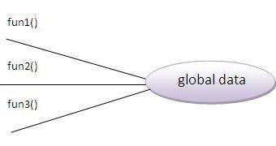 | 